| Ousmane Toure and Jianning Chen  EECE2160 | Embedded Design: Enabling Robotics  Prelab Assignment 2 |
| --- | --- |

Prelab Assignment 2

Lab Report Template and Guide

Ousmane Toure & Jianning Chen

Toure.o@northeastern.edu

chen.jiann@northeastern.edu

Submit date: 5/17/2022

Due Date: 5/18/2022

**2.1 Screenshot of Pre-Lab Assignment**

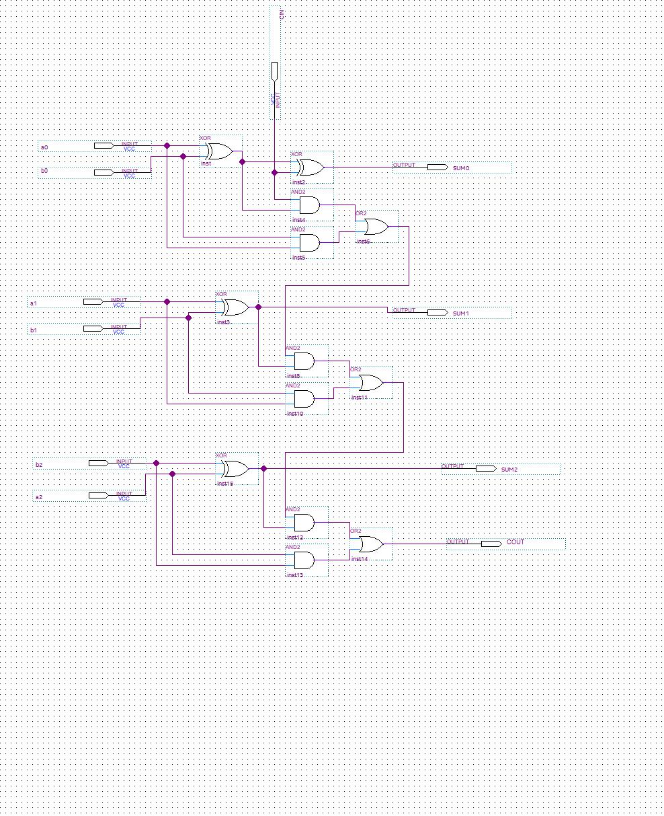

**References**

1. Prof. Julius Marpaung, “*Lab Report Guide*”, Northeastern University, January 6 2020.
2. *“Full adder in digital logic”,* GeeksForGeeks, November 25, 2019, https://www.geeksforgeeks.org/full-adder-in-digital-logic/